**Compliance and Regulatory Affairs in U.S. Banking Operations**

Compliance and regulatory affairs in banking refer to the adherence to laws, regulations, guidelines, and specifications relevant to banking operations. These regulations are designed to ensure the safety, soundness, and integrity of financial institutions, protect consumers, and maintain the stability of the financial system.

**Key Components of Compliance and Regulatory Affairs**

1. **Regulatory Compliance**:
   * Ensuring that all banking operations comply with federal, state, and local laws and regulations.
   * Regular updates and training on regulatory changes and new requirements.
2. **Risk Management**:
   * Identifying, assessing, and mitigating risks associated with non-compliance.
   * Implementing robust internal controls and monitoring systems.
3. **Anti-Money Laundering (AML) and Counter-Terrorist Financing (CTF)**:
   * Establishing programs to detect and prevent money laundering and terrorist financing activities.
   * Reporting suspicious activities to the relevant authorities.
4. **Consumer Protection**:
   * Adhering to laws designed to protect consumers, such as the Truth in Lending Act (TILA) and the Fair Credit Reporting Act (FCRA).
   * Ensuring transparent and fair treatment of customers.
5. **Data Privacy and Protection**:
   * Complying with data protection regulations such as the Gramm-Leach-Bliley Act (GLBA) and the California Consumer Privacy Act (CCPA).
   * Safeguarding customer information against breaches and misuse.
6. **Corporate Governance**:
   * Implementing policies and procedures to ensure ethical conduct and decision-making within the organization.
   * Maintaining transparency and accountability in business practices.
7. **Regulatory Reporting**:
   * Timely and accurate reporting of financial and operational information to regulatory authorities.
   * Maintaining records and documentation for regulatory reviews and audits.

**Key Regulatory Bodies in the U.S.**

1. **Federal Reserve System (FRS)**:
   * Oversees and regulates banks and bank holding companies.
   * Conducts monetary policy and ensures financial stability.
2. **Office of the Comptroller of the Currency (OCC)**:
   * Regulates and supervises national banks and federal savings associations.
3. **Federal Deposit Insurance Corporation (FDIC)**:
   * Insures deposits at banks and thrifts.
   * Supervises financial institutions for safety, soundness, and consumer protection.
4. **Consumer Financial Protection Bureau (CFPB)**:
   * Protects consumers by enforcing federal consumer financial laws.
   * Ensures transparency and fairness in consumer financial products and services.
5. **Securities and Exchange Commission (SEC)**:
   * Regulates and oversees securities markets and protects investors.

**Compliance Strategies in Banking**

1. **Compliance Programs**:
   * Developing comprehensive compliance programs that address all relevant regulations and guidelines.
   * Regularly updating programs to reflect changes in the regulatory landscape.
2. **Training and Awareness**:
   * Providing ongoing training for employees on compliance policies and procedures.
   * Promoting a culture of compliance within the organization.
3. **Internal Audits and Monitoring**:
   * Conducting regular internal audits to assess compliance with regulations.
   * Implementing continuous monitoring systems to detect and address potential compliance issues.
4. **Technology and Automation**:
   * Utilizing advanced technologies such as artificial intelligence and machine learning to enhance compliance monitoring and reporting.
   * Automating routine compliance tasks to improve efficiency and accuracy.

**Example: Wells Fargo Compliance Efforts**

**Wells Fargo** has made significant efforts to strengthen its compliance and regulatory affairs in response to past regulatory issues. Here’s how they have addressed compliance:

* **Enhanced Risk Management Framework**:
  + Wells Fargo has overhauled its risk management framework to ensure better oversight and control of compliance risks.
  + The bank has increased its focus on internal controls and monitoring.
* **Strengthened AML and CTF Programs**:
  + The bank has invested in advanced technologies to enhance its AML and CTF programs.
  + Wells Fargo has increased its staff dedicated to monitoring and reporting suspicious activities.
* **Consumer Protection Initiatives**:
  + Wells Fargo has implemented new policies to ensure fair and transparent treatment of customers.
  + The bank has enhanced its customer complaint resolution processes.
* **Corporate Governance Improvements**:
  + The bank has restructured its governance framework to ensure greater accountability and transparency.
  + Wells Fargo has increased board oversight of compliance and risk management activities.

**Trends in Regulatory Fines**

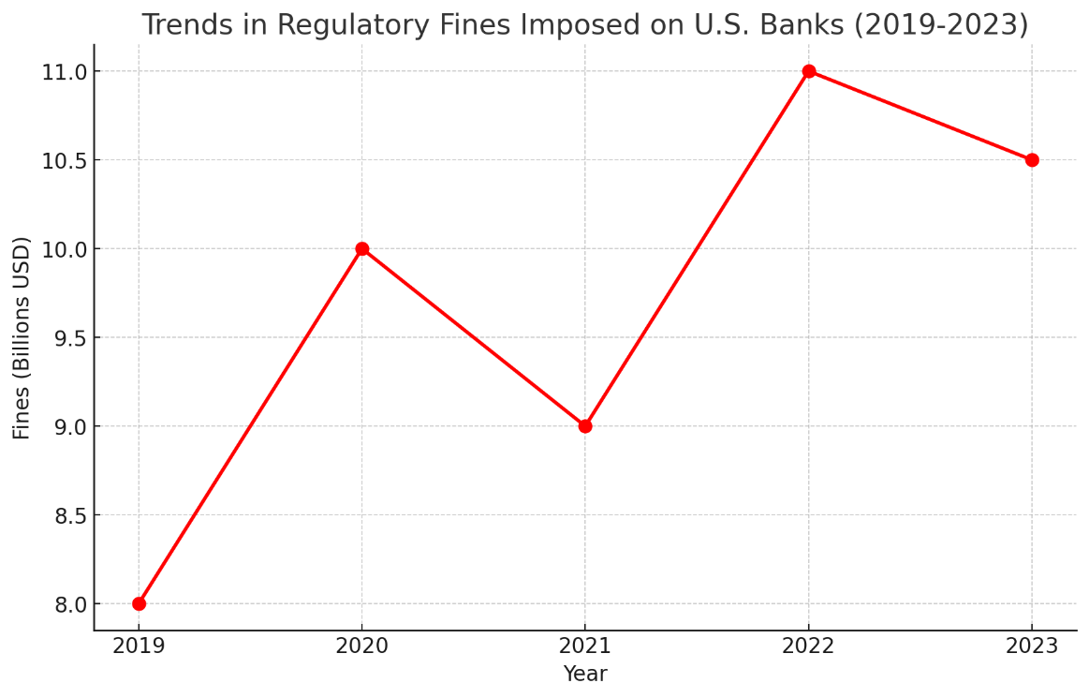

**AML Compliance Improvements**

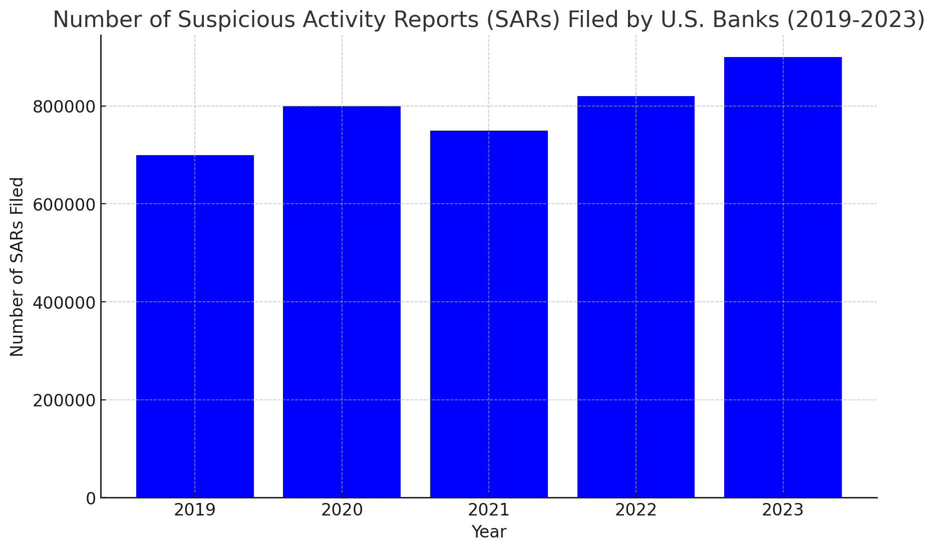

**Consumer Complaint Resolution**:

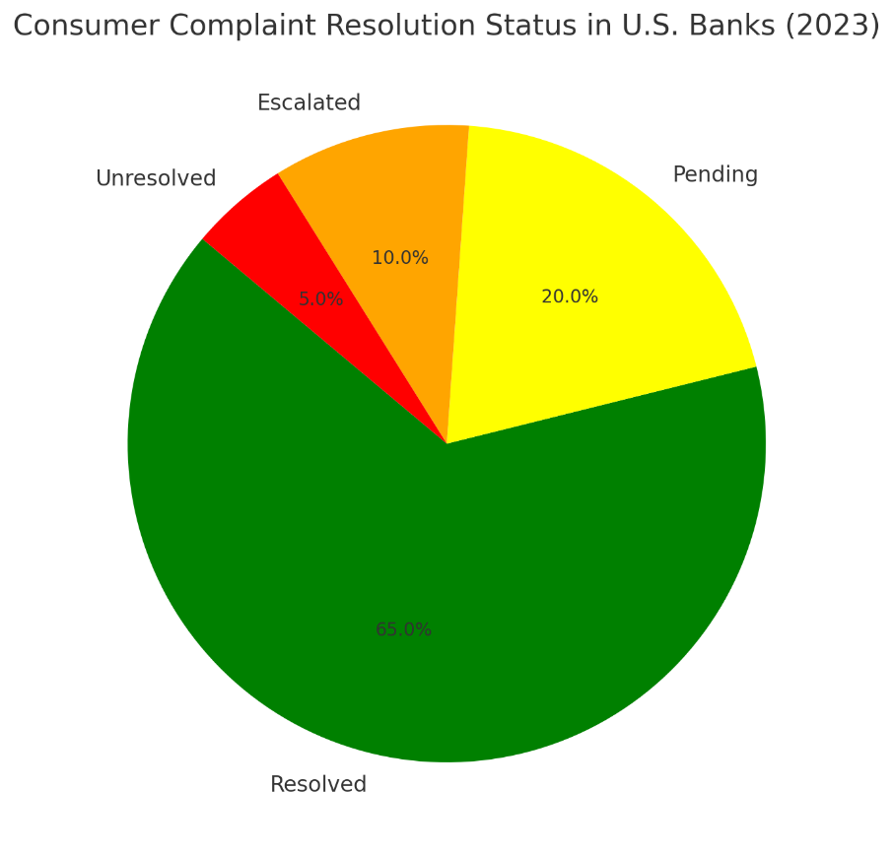

* **Trends in Regulatory Fines**:

This line graph shows the trend in the total regulatory fines imposed on U.S. banks from 2019 to 2023. The data indicates fluctuations with a peak in 2022, followed by a slight decrease in 2023.

* **AML Compliance Improvements**:

This bar chart depicts the number of Suspicious Activity Reports (SARs) filed by major U.S. banks over the past five years. The data shows a significant increase in SAR filings, reflecting enhanced efforts in AML compliance.

* **Consumer Complaint Resolution**:

This pie chart presents the resolution status of consumer complaints in the banking sector for the year 2023. It highlights that 65% of complaints were resolved, 20% are pending, 10% were escalated, and 5% remain unresolved.

**Statistical Insights:**

1. **Capital Adequacy and Safety Standards**: Adoption of Basel III standards is expected to significantly increase the capital held by U.S. banks. Large banks may see their minimum capital requirements rise by up to 20% to meet these new standards.
2. **Consumer Protection Efforts**: The introduction of new fair lending regulations could impact millions of consumers. For instance, enhancing open banking frameworks is expected to benefit around 100 million U.S. bank customers by providing more secure and transparent access to financial services.
3. **Operational Resilience**: The financial sector spends approximately $100 billion annually on cybersecurity. New regulations are likely to increase this expenditure by 15-20% as banks enhance their cybersecurity and third-party risk management protocols.